**Lab - Creating and Managing Objects in Active Directory**

**Overview**

In this lab, you will learn to add objects to Active Directory to include users, groups, containers, and computers. This lab applies to Windows Server 2012r2, 2016 and 2019.

**Creating Organizational Units**

1. Logon to Active Directory Server full GUI as an Administrator
2. From Server Manager, click on tools

3. Open the Active Directory User and Computers snap-in

4. Expand your domain name

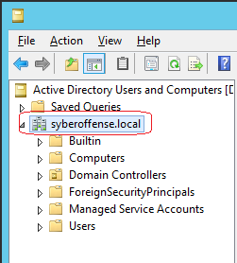

5. Right-Click your domain name and choose New and Select Organizational Unit

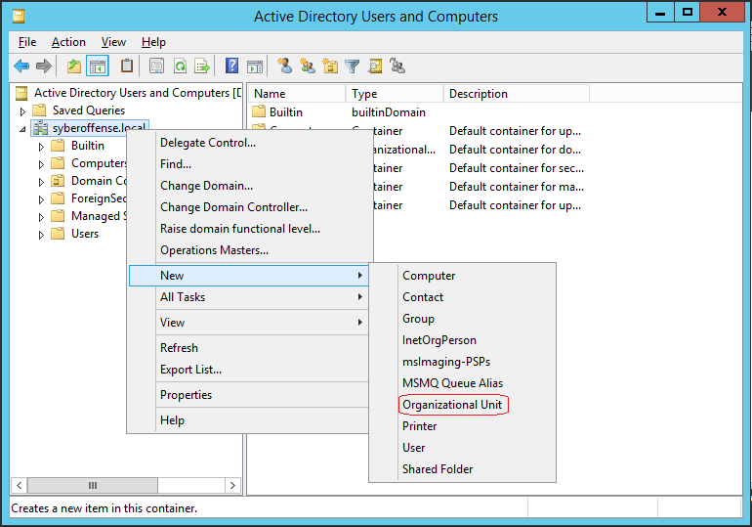

6. Type the name of the Organizational Unit: Employees

7. Select Protect Container from Accidental Deletion

8. Click OK

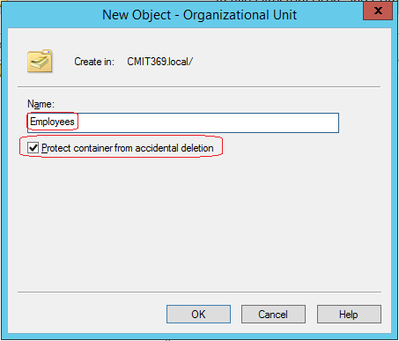

9. Right-click the OU and Choose Properties

10. In the Description field, type Non-administrative users

11. Click OK

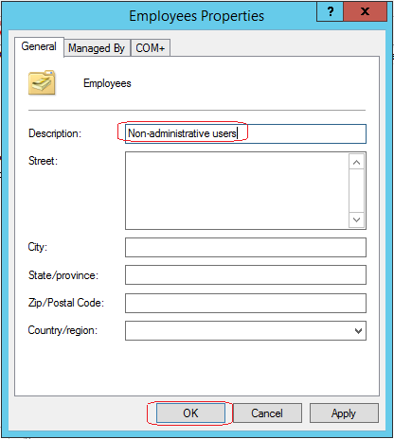

12. Create the following OUs

|  |  |
| --- | --- |
| OU name | OU Description |
| Desktops | Desktop Computers |
| Groups | Non-administrative groups |
| Admins | Administrative groups |
| Servers | Servers |
| Laptops | Laptop computers |

**Creating Users**

1. Right-Click your domain name and select New User. Input the following information into the user's properties.

|  |  |  |  |  |
| --- | --- | --- | --- | --- |
| First Name | Last Name | Logon Name | Name Password | Change Password |
| Dan | Holme | dholme | Password123! | Yes |
| Robert | Redford | rredford | Password123! | Yes |
| Barbara | Bush | bbush | Password123! | Yes |
| Linda | Mills | lmills | Password123! | Yes |
| Jackie | Roberts | jroberts | Password123! | Yes |

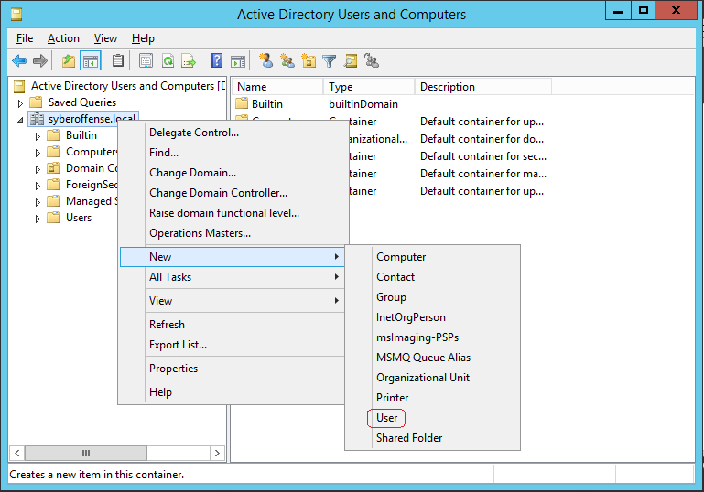

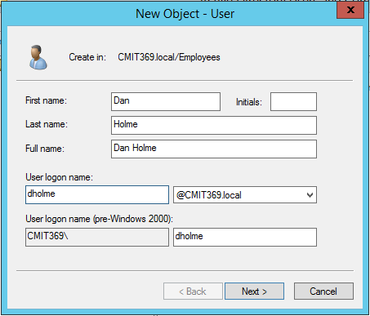

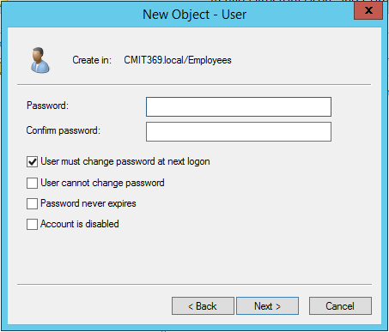

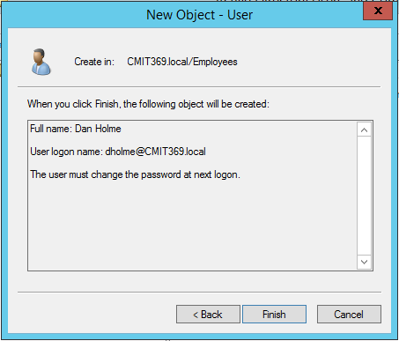

**Creating Computers**

1. Right-Click Servers OU and Select New Computer

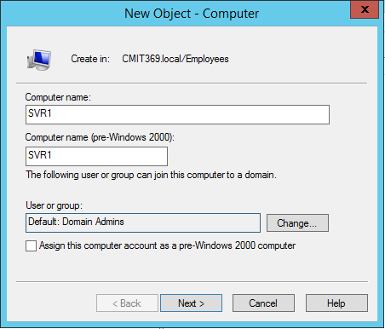

2. In the Computer name box, type SVR1 and Click Next, Next and Finish

3. Right-Click the SRV1 and choose Properties

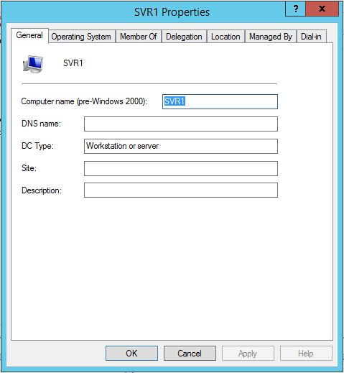

4. Just look at properties do not change any

5. Click OK

6. Create the following computers:

|  |  |
| --- | --- |
| Computer Name | OU |
| EX1 | Server |
| SharePoint01 | Server |
| Desktop01 | Desktops |
| Desktop02 | Desktops |
| Laptop01 | Laptops |
| Laptop02 | Laptops |

**Create Groups**

1. Right-click the Groups OU and Select New Group

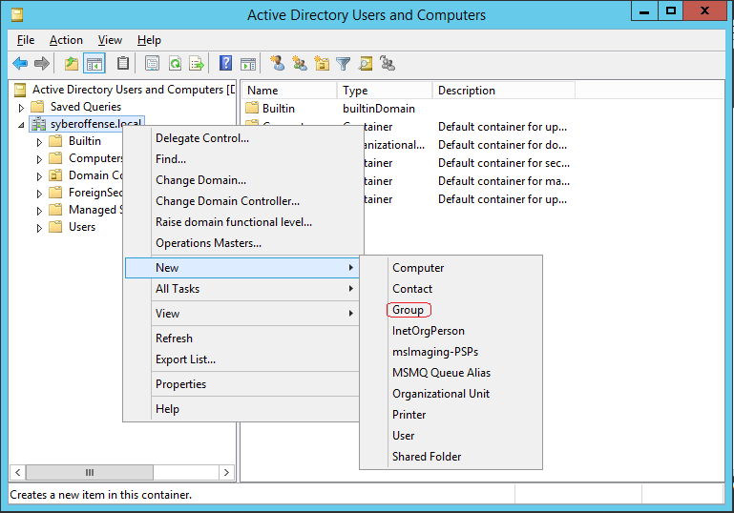

2. Type Finance for the Group Name

3. Do not change the name of the Group Name (Pre-Windows)

4. Select Security for Group Type

5. Select Global for the Group Scope

6. Click OK

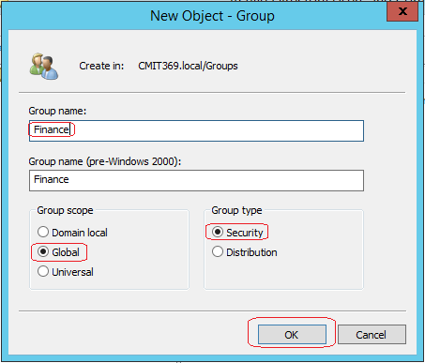

7. Right-Click Finance Group and select Properties

8. Examine the Properties but do not change them

9. Click OK

10. Create the following groups in Groups OU

|  |  |  |
| --- | --- | --- |
| Group name | Group Type | Group Scope |
| Finance Managers | Security | Global |
| Sales | Security | Global |
| APP Office 2016 | Security | Global |

11. Create the following groups in Admins OU

|  |  |  |
| --- | --- | --- |
| Group name | Group Type | Group Scope |
| Help Desk | Security | Global |
| Windows | Security | Global |

**Adding Users and Computers to Groups**

1. Right-Click the Help Desk group and Select Properties

2. Click the Members Tab

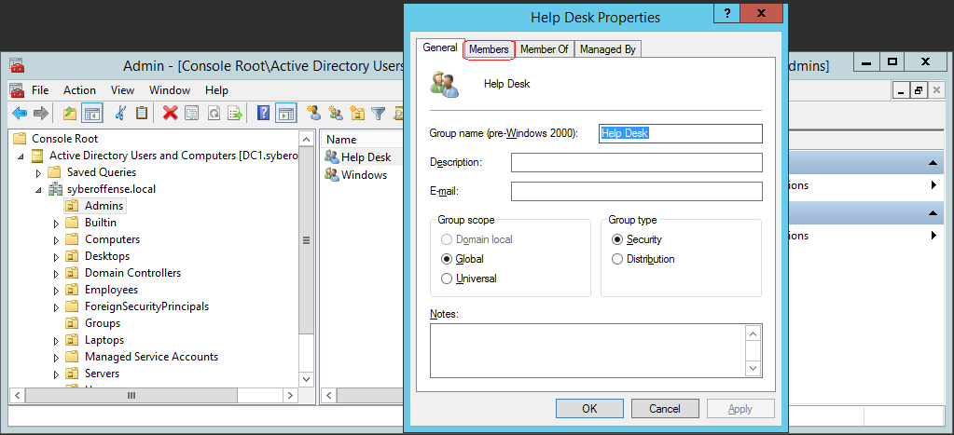

3. Click Add Button

4. In the Select dialog box, type Robert

5. Click Check Names

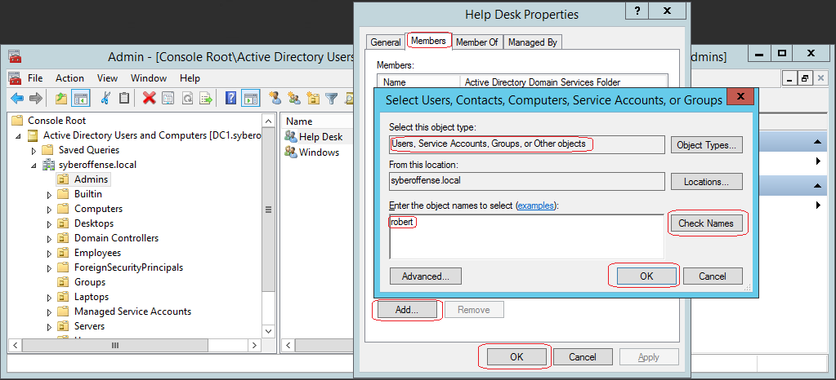

6. Select Robert Redford

7. Click OK to close the Select dialog box

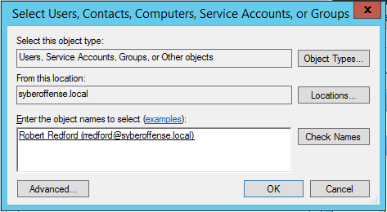

8. Click OK again to close the group properties

9. Open the Groups OU, right-click the APP Office 2016 group and select properties

10. Click the Members Tab

11. Click Add

12. In the Select dialog box, Select Desktop01

13. Click Check Names

14. Click Cancel

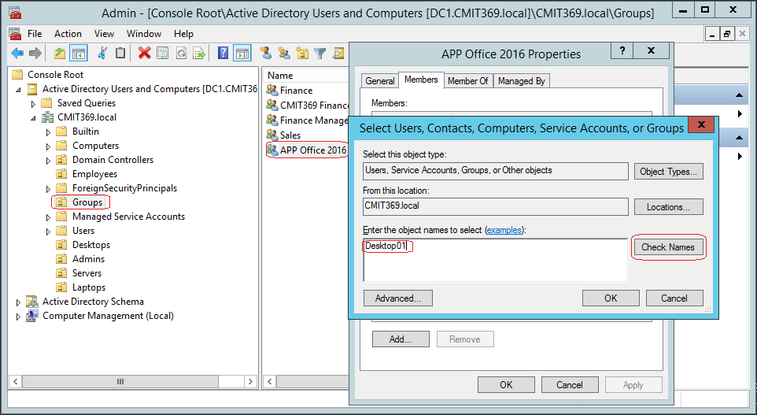

**a. Name Not Found Box**

15. In the Select box, Click Object Types

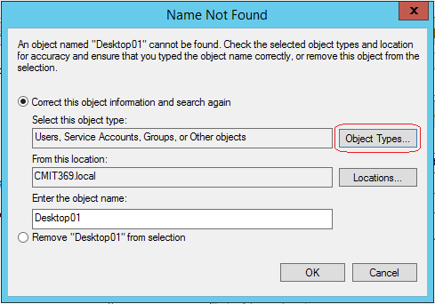

16. Select Computers as an object Click OK

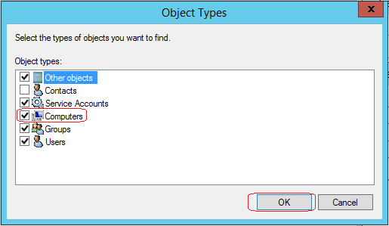

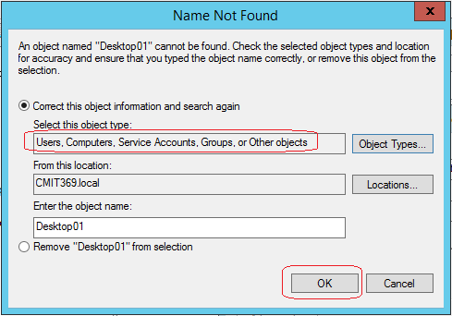

17. Click Check Names

1. **Name will resolve**

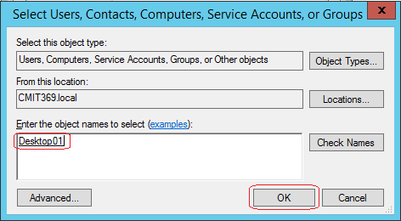

18. Click OK

**Finding Objects in Active Directory**

1. Right-Click on your Domain name click Find

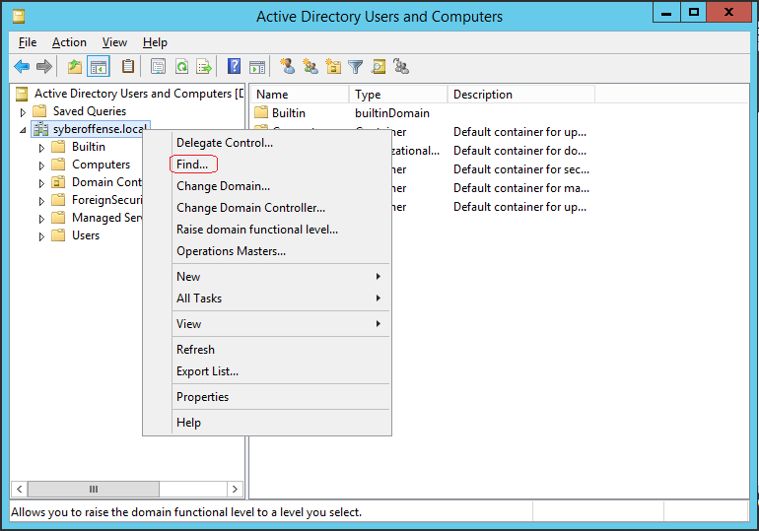

2. In the Name Box, type Barb

3. Click Find Now and close the window

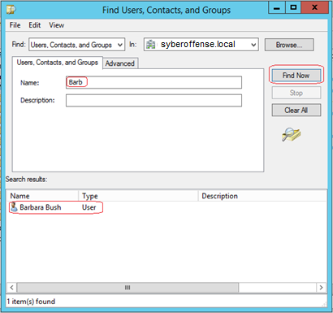

4. In the left window pane, right-click Saved Queries Node

5. Choose New and choose Query

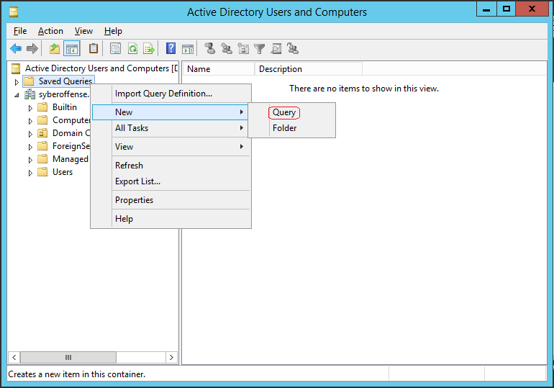

6. Type All Users in the Name Box

7. Description box type User for the entire domain

8. Click Define Query

9. On the Users tab, in the Name box, choose Has A Value

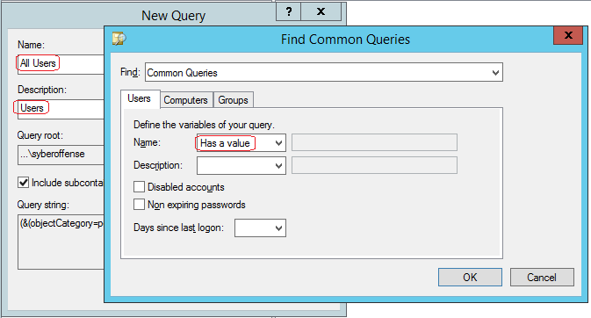

10. Click OK twice to close the dialog boxes

11. Choose View, and then click Add/Remove Columns

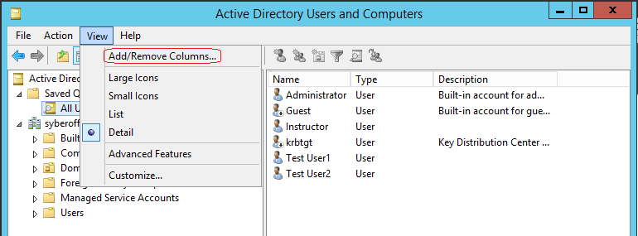

12. In the Available columns list, Select the Last Name and click the Add Button

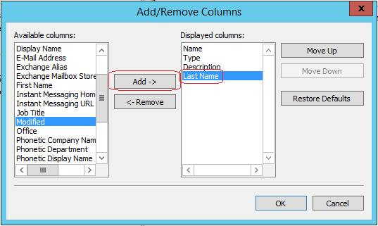

13. In the Displayed columns list, Select Type and click the Remove button

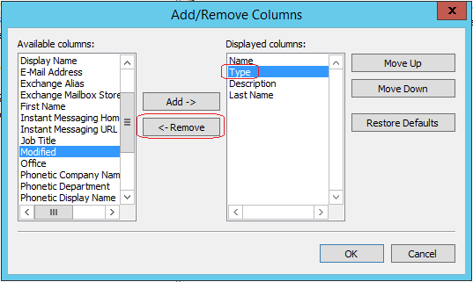

14. Click OK

15. Drag the Last Name Colum heading so that it is between Name and Description

16. Click the Last Name column heading to sort it alphabetically by the last name

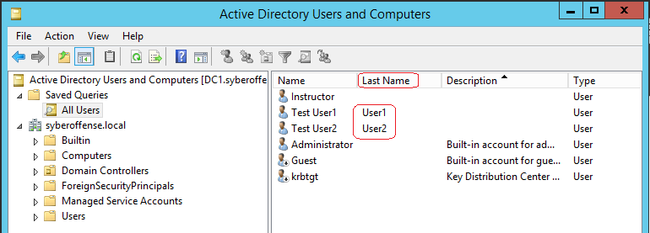

**Add Users to Active Directory Using PowerShell**

From the desktop, launch PowerShell.

**Create a single new user account using PowerShell**

To create a new user account for Sam Spade using sspade for the user’s SAM account name and [sspade@syberoffense.local](mailto:sspade@syberoffense.local) for the user’s UPN logon, you can use the New-ADUser cmdlet as follows:

Notice we set the password and forced the user to change it at first login. You can copy and paste the following into PowerShell. The important take away was the name the CMDLET we used, the New-AdUser. You might see this again on the 70-410 exam.

New-ADUser -Name “Sam Spade” -GivenName Sam -Surname Spade -SamAccountName sspade -UserPrincipalName sspade@syberoffense.local -AccountPassword (ConvertTo-SecureString -AsPlainText “PassW0rD” -Force ) -Enabled $true -ChangePasswordAtLogon $true

You can verify the account creation by using the **Get-ADUser -Identity sspade** command.

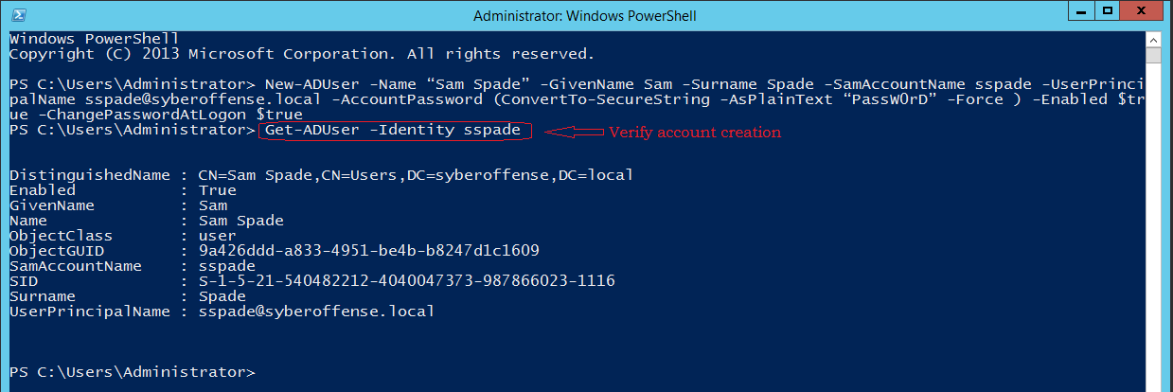

The following cmdlets are also helpful for managing user accounts using PowerShell.

**When you need to disable an account quickly:**

**Disable-ADAccount -Identity sspade**

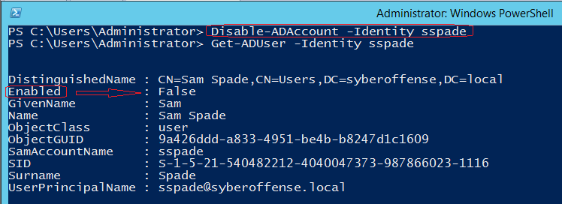

**When you need to enable an account.**

**Enable-ADAccount -Identity sspade**

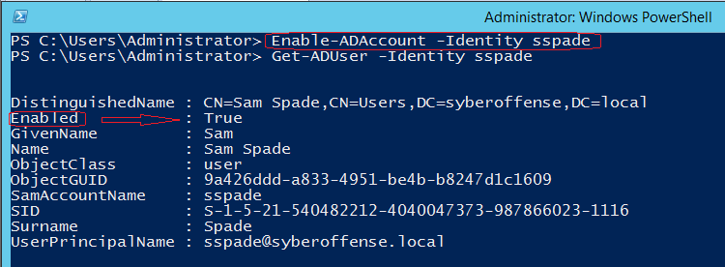

**Reset the password of an account.**

When a user forgets their password, you can use the following command to reset.

Set-ADAccountPassword -Identity sspade -Reset

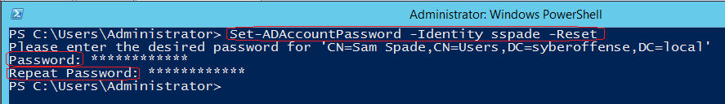

PowerShell returns the following message:

Please enter the desired password for ‘CN=Sam Spade,CN=Users,DC=syberoffense,DC=local’

**Remove a User Account.**

**Remove-ADUser -Identity sspade**

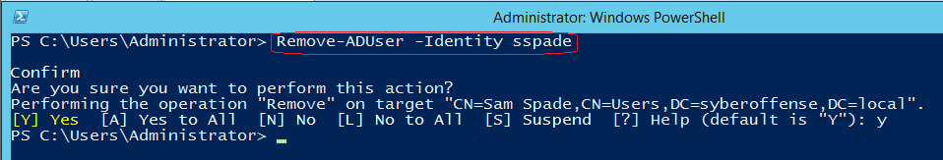

**Add a user as a member of a group.**

Create a new user using PowerShell, verify the account, and then add the user to the administrator's group using the following command.

Add New user. Create a new user replacing the words in red with the user’s correct information.

New-ADUser -Name “Sam Spade” -GivenName Sam -Surname Spade -SamAccountName sspade -UserPrincipalName sspade@syberoffense.local -AccountPassword (ConvertTo-SecureString -AsPlainText “PassW0rD” -Force ) -Enabled $true -ChangePasswordAtLogon $true

**Add the new user to the administrators group**

Add-ADGroupMember -Identity administrators -Member sspade



Verify the user is a member of administrators group.

ADGroupMember administrators

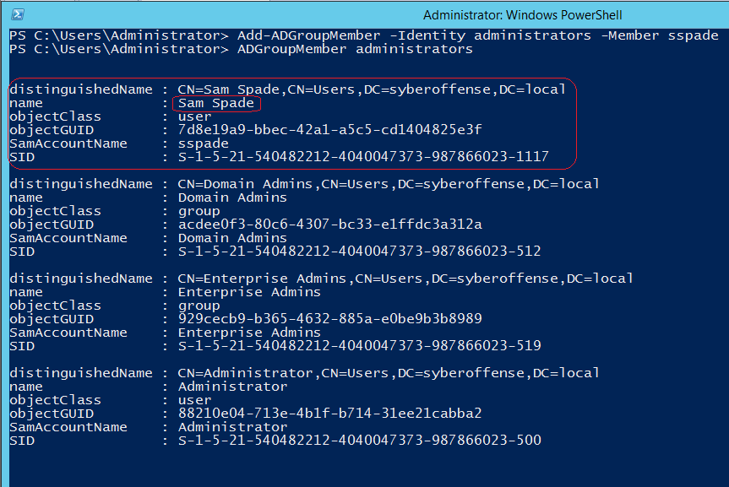

End of the lab!